# Enhancement of Sales in a Store by evaluating measures using Statistical Testing

Date: 20-09-2013

Submitted to:  
Prof. Dega Naga Raju  
SMBS

Submitted by:  
Vamsi Krishna(10BCE0022)  
Soma Akhil (10BCE0501)  
Saketh P(10BCE0495)  
Sujan Reddy(10BCE0364)

# Introduction:

Considering the sales at a departmental store or any shopping mart, Customers prefer to shop at the stores where there’s high product quality, good infrastructure, good facilities, better parking space lot, hygienic conditions. There may be many reasons for customers to not prefer to shop at a particular shopping mart. Some reasons may include due to less quality products, unhelpful staff and poor infrastructure and facilities. These may be counted as small reasons but when looked as a whole, they might have an impact on customers in choosing the shopping marts.  
 Let us consider a shopping mart ‘X’ whose sales dipped by 20% over the past 3 years due to the above stated reasons. This makes the company lose out on their competitors as they were not able to meet the customer’s requirements and hence the revenue sales were decreased. So, a study is required to analyze the current scenario by collecting and reviewing the data and information obtained from both shopping mart and customers(treated as sample-data).   
 This project is to give a clear insight on the situation and suggesting the ways to help improvise the current situation. The suggestion is done based on statistical analysis on various parameters (like price discounts, better infrastructure, offers, ample parking space, number staff) that may increase/decrease the revenue of the departmental store. This will be found using two sample sign tests-Statistical Testing.

# Situation Summary:

X is a shopping mart/departmental store which provides customers a wide range of products for every field. The record books read that there’s a dip in the revenue sales of the company for the past 3 years. This is causing a problem for the management since they’re trying to expand their company but they are losing out to their competitors due to various reasons like lack of quality products, attractive offers, proce discounts etc. So, measures are to be suggested for improving the functioning of the store and increasing the annual revenue sales of products.

# Problem Statement :

Over the past 3 years, shopping mart ‘X’ is losing to its competitors. This can be depicted from their revenue sales. The revenue sales dipped over 20% over past 3 years. Necessary measures are to be provided to help improve the current status and increase the economy of the company.

# Data Collection and Analyzation:

1. Familiarity

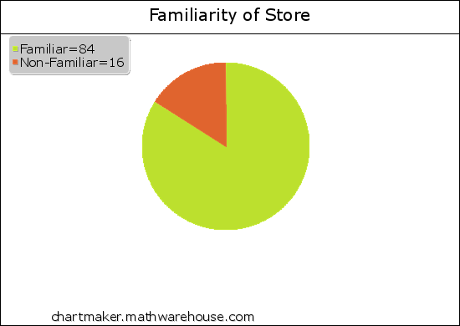

1. Product Quality

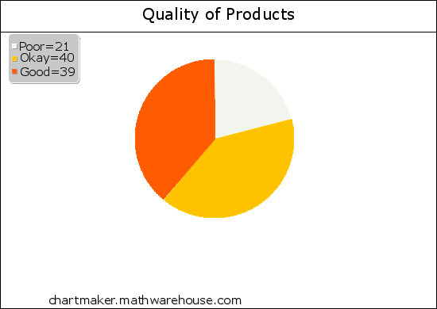

1. Branches accounting for Revenue:

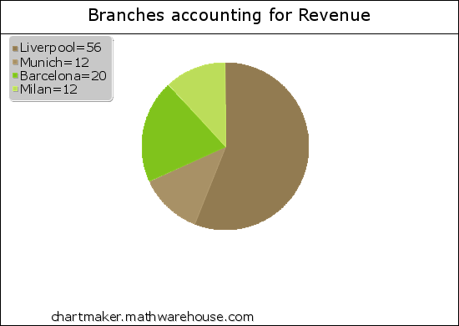

1. Frequency of Visits:

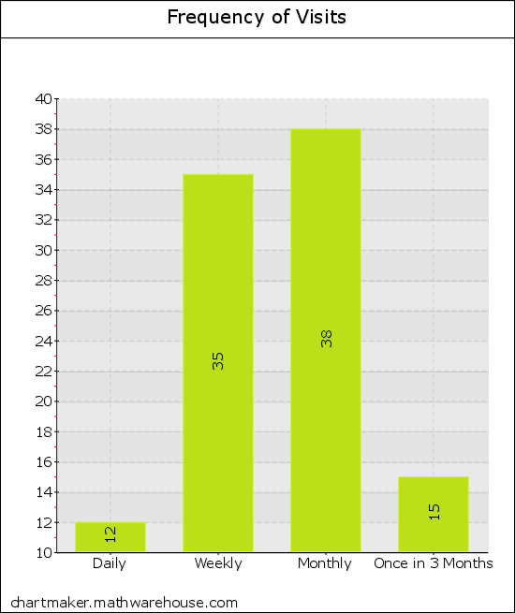

1. Parameter Evaluation

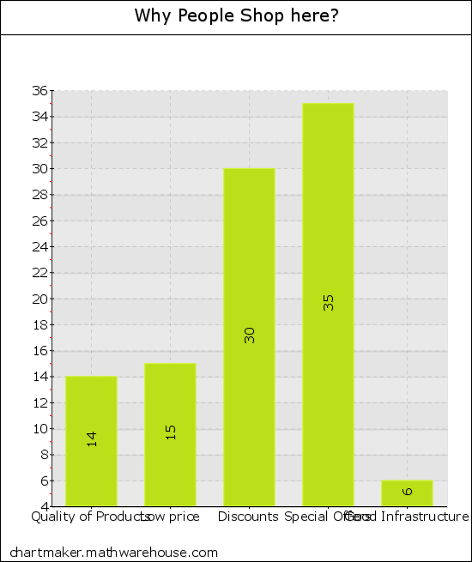

# Statistical Testing-Sign Test:

In statistics, the sign test can be used to test the hypothesis that there’s “no difference in medians” between two continuous distributions of two random variables X and Y, in a situation where we can draw X and Y pairs. It is a non-parametric test and hence makes very less assumptions about the nature of distributions under test.

# Methodology:

In general, the customers shopping interest is based on five parameters.  
(1) Discount.  
(2) Offers on products  
(3) Private Labels  
(4) Home delivery  
(5) Better Infrastructure and Quality staff.

Let us take a deeper insight on how the discount offered on products would affect the revenue sales. A sample raw data is used for evaluation.  
  
**Step-(1)**

From the table below, if 1st value > 2nd value then ‘+’ sign else ‘-‘ .

**Step-(2)**  
Count the no.of ‘+’ and ‘-‘ signs.

No. of ‘+’ sings=2

No. of ‘-‘ signs=2

|  |  |  |  |
| --- | --- | --- | --- |
| Store-Branch | Before Discount | After Discount | Sign Allotted |
| Liverpool | 7 | 8 | - |
| Munich | 23 | 16 | + |
| Barcelona | 12 | 14 | - |
| Milan | 9 | 5 | + |

**Step-(3)**  
n=No. of observations  
p=p-value=0.5  
Calculate n*p=4*(0.5)=2

**Step-(4)**  
**Hypothesis Testing**-  
(i) **Null Hypothesis**:- “There is no significant difference in sales revenue when there is a price discount.”-H0  
(ii) **Alternate Hypothesis**:- “There is a difference in sales revenue when there is a price discount”-H1

(iii) **Test Results**:  
Let x- No. of + signs.  
P(x)- Probability of achieving ‘x’ + signs.  
P(2)= 4C2(1/2)2(1/2)2 = 0.375  
P(3)= 4C3(1/2)3(1/2) = 0.25

P(4)= 4C4(1/2)4(1/2)0 = 0.0625  
 Now, z= P(2)+P(3)+P(4) = 0.375+0.25+0.0625= 0.6875.

(iv**) Level of Significance**:  
At 5% level, table value of z= 0.64 < Zcal.

(v) **Decision**:  
Since z<Z(cal), accept H0.  
(vi) **Conclusion**:  
Therefore, the price discounts do not account or significantly change the revenue sales of the shopping mart.

The same test has been applied to the different parameters data sets and results obtained using MATLAB-Hypothesis testing tool are tabulated below.

|  |  |
| --- | --- |
| Parameter | Result |
| Price Discount |  |
| Offers on products |  |
| Private Labels |  |
| Home Delivery |  |
| Better Infrastructure |  |